**Phase 3 — Data Modeling & Relationships**

**1. Create Custom Objects**

**Setup → Object Manager → Create → Custom Object**

* **Donor** → Donor__c → Record Name: Text (Donor Name)
* **NGO** → NGO__c → Record Name: Text (NGO Name)
* **Food Donation** → Food_Donation__c → Record Name: Auto Number: DON-{0000}
* **Pickup Request** → Pickup_Request__c → Record Name: Auto Number: PCK-{0000}

**2. Add Fields to Objects**

**Setup → Object Manager → Select Object → Fields & Relationships → New**

**For Donor (Donor__c):**

* Email (Text)
* Phone (Phone)
* Address (Text Area)

**For NGO (NGO__c):**

* Location (Text)
* Contact Person (Text)
* Capacity (Number)

**For Food Donation (Food_Donation__c):**

* Donation Date (Date)
* Quantity (Number)
* Food Type (Picklist: Perishable, Non-Perishable)
* Donor (Lookup → Donor)

**For Pickup Request (Pickup_Request__c):**

* Request Date (Date)
* Status (Picklist: Pending, Approved, Completed)
* NGO (Lookup → NGO)
* Food Donation (Lookup → Food Donation)

**3. Relationships**

* **Food Donation → Lookup → Donor**  
  → Each donation is linked to a Donor.
* **Pickup Request → Lookup → Food Donation**  
  → Each request is linked to a donation.
* **Pickup Request → Lookup → NGO**  
  → Each request is linked to an NGO.

**4. Record Types**

**Setup → Object Manager → Food Donation → Record Types → New**

* **Perishable Donation** → Default for Volunteers
* **Non-Perishable Donation** → Available for All Profiles

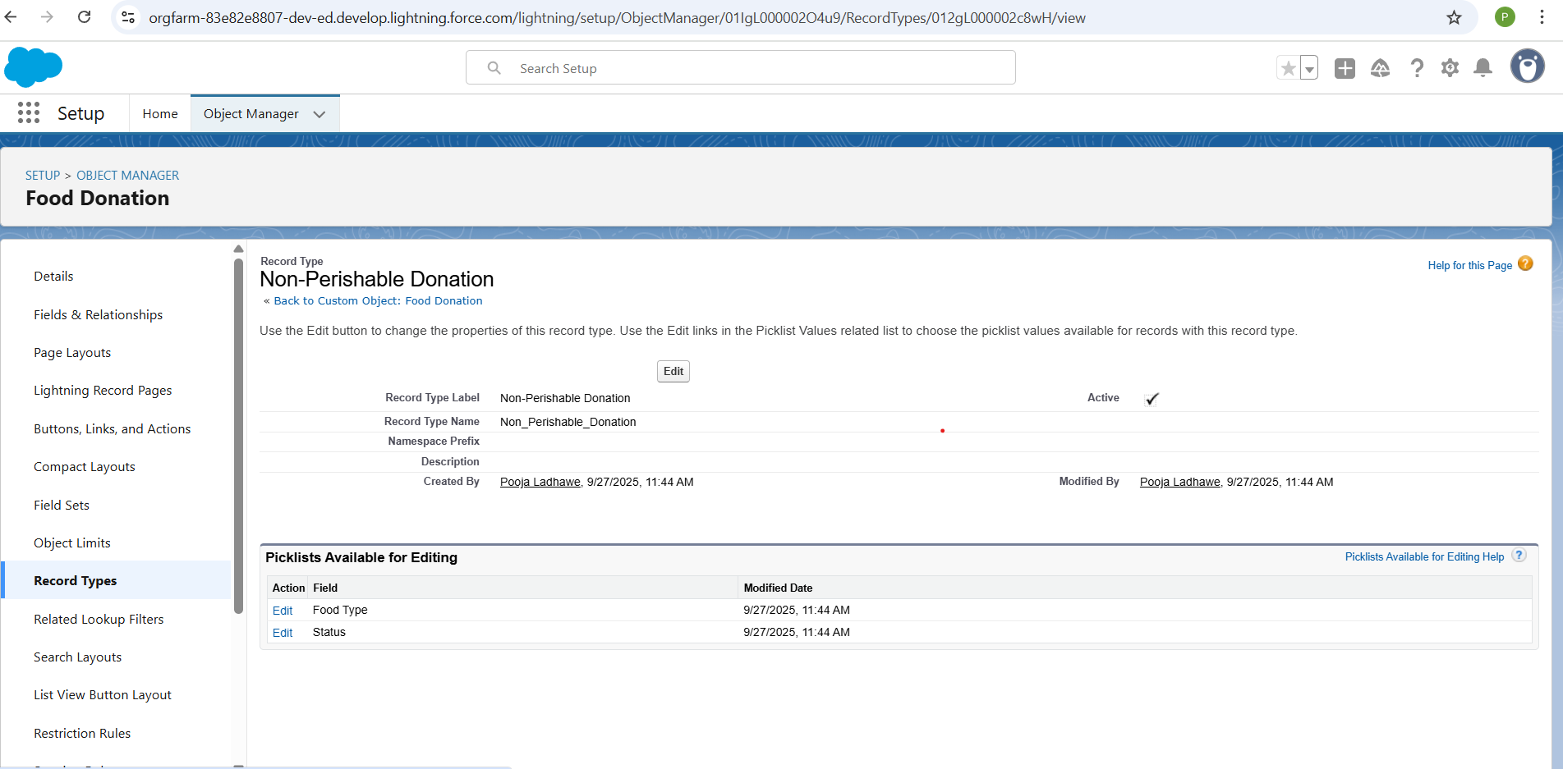

**Step 4: Page Layouts**

**Purpose: How the record looks on the screen.**

**Steps:**

1. **Object Manager → Select Object → Page Layouts → Edit**
2. **Drag fields into sections: “Donation Details”, “Donor Info”**
3. **Drag Related Lists (e.g., Pickup Requests)**
4. **Click Save**

**Step 5: Compact Layouts**

**Purpose: Fields that appear in the top highlights of a record.**

**Steps:**

1. **Object Manager → Select Object → Compact Layouts → New**
2. **Name it → Add key fields (e.g., Donor Name, Email, Donation Date)**
3. **Save → Set as Primary**

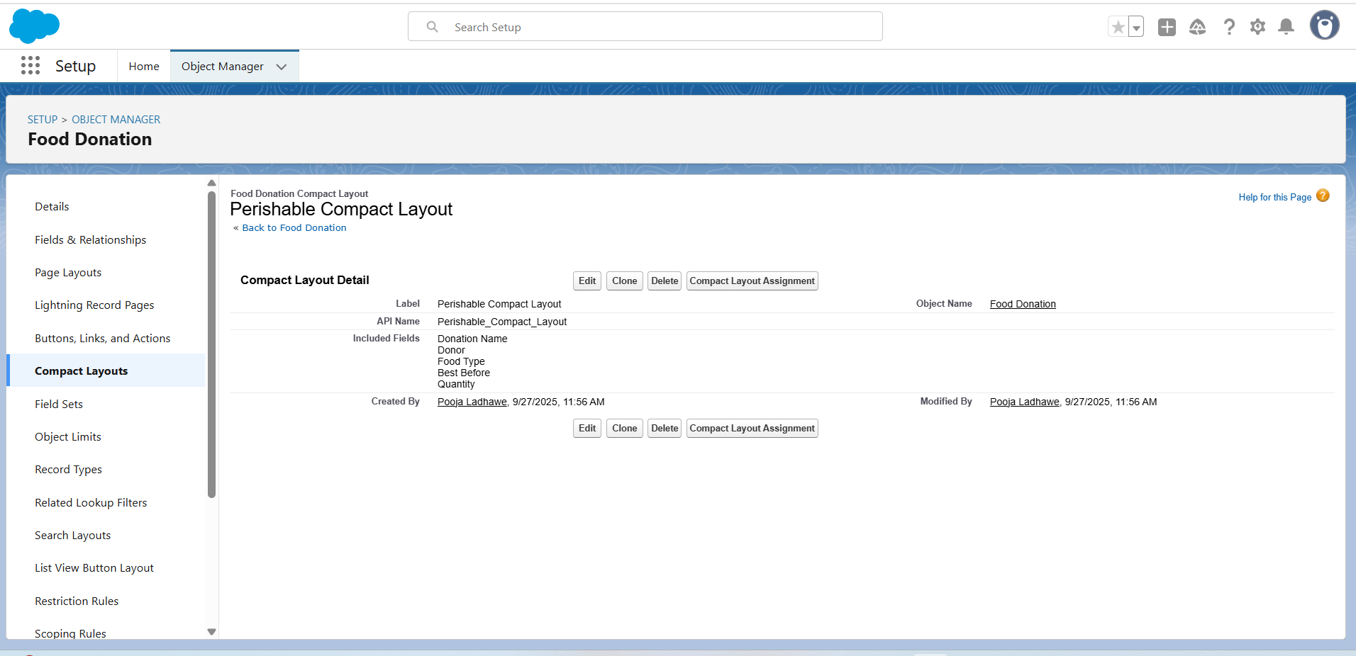

**6. Field-Level Security**

**Setup → Object Manager → Food Donation → Fields & Relationships → Select Field → Set Field-Level Security**

* **Volunteer:** Can see Donor Name, Quantity, Food Type (Read-only).
* **NGO Manager:** All fields visible.
* **Admin:** Full access.

**7. Related Lists & Buttons**

**Setup → Object Manager → Food Donation → Page Layouts → Edit Layout**

* **Pickup Requests →** Request Date, Status
* **Activity History →** Subject, Status, Due Date
* **Quick Actions →** New Pickup Request, New Task

**8. Schema Builder Verification**

**Setup → Schema Builder → Add Donor, NGO, Food Donation, Pickup Request**

* **Food Donation → Lookup → Donor**
* **Pickup Request → Lookup → Food Donation**
* **Pickup Request → Lookup → NGO**

